GPT Remediation creator

Remediations play a pivotal role in effective client management, allowing organizations to proactively identify and resolve end-user issues. Additionally, they serve as a valuable tool for enforcing specific settings or configurations that may not be natively supported in Microsoft Intune. However, the process of crafting these scripts can often be intricate and time-consuming.

Imagine a solution where you can simply describe your desired configurations, and a tool generates the necessary scripts for you. If you find this idea appealing and are keen to explore such a solution, this blog is tailored to meet your exact needs.

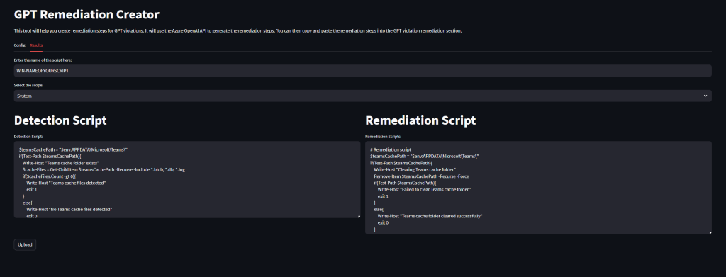

Content

1. [Content](https://jannikreinhard.com/2023/12/28/gpt-remediation-creator/#content)
2. [Get the Tool](https://jannikreinhard.com/2023/12/28/gpt-remediation-creator/#get-the-tool)
3. [What is the GPT Remediation creator?](https://jannikreinhard.com/2023/12/28/gpt-remediation-creator/#what-is-the-gpt-remediation-creator)
4. [What are the prerequisites](https://jannikreinhard.com/2023/12/28/gpt-remediation-creator/#what-are-the-prerequisites)
5. [How does the tool work](https://jannikreinhard.com/2023/12/28/gpt-remediation-creator/#how-does-the-tool-work)
6. [How to get access to Open AI Service](https://jannikreinhard.com/2023/12/28/gpt-remediation-creator/#how-to-get-access-to-open-ai-service)
7. [How it the data privacy when I use the Azure Open AI service](https://jannikreinhard.com/2023/12/28/gpt-remediation-creator/#how-it-the-data-privacy-when-i-use-the-azure-open-ai-service)
8. [How to start the GPT Intune Device Troubleshooter](https://jannikreinhard.com/2023/12/28/gpt-remediation-creator/#how-to-start-the-gpt-intune-device-troubleshooter)
9. [How you can contribute?](https://jannikreinhard.com/2023/12/28/gpt-remediation-creator/#how-to-create-a-app-registration)

Get the Tool

[Git Hub](https://github.com/JayRHa/Remediation-Creator)

<https://github.com/JayRHa/Remediation-Creator>

What is the GPT Remediation creator?

In the end, the process is remarkably straightforward. The tool generates a detection script and, if desired, a remediation script based on your provided description. It then seamlessly uploads these scripts to your tenant, streamlining the entire process.

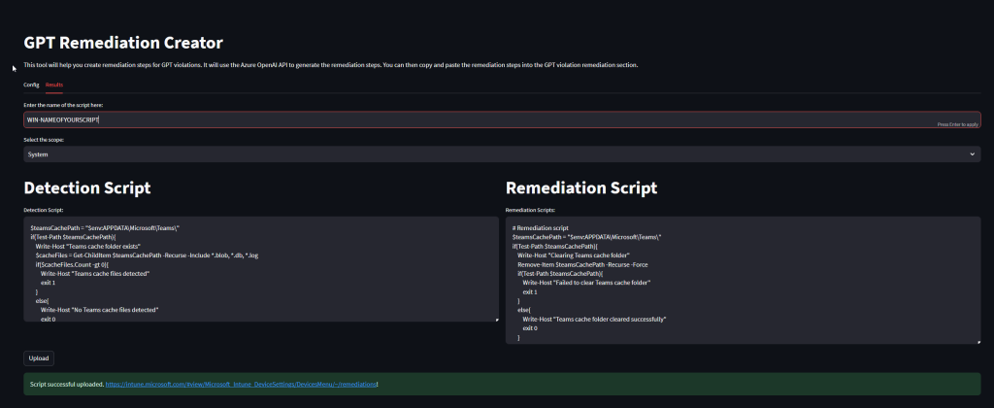

What are the prerequisites

The prerequisites for getting started are minimal. All you need is a GPT-enabled subscription. Once you have this, you’ll need to create an Azure OpenAI Service deployment. After completing this step, you can easily add the relevant information to your ‘secrets.toml’ file. To do this, simply rename ‘secrets.toml.example‘ to ‘secrets.toml‘.

Another prerequisite is that python is installed on the system.

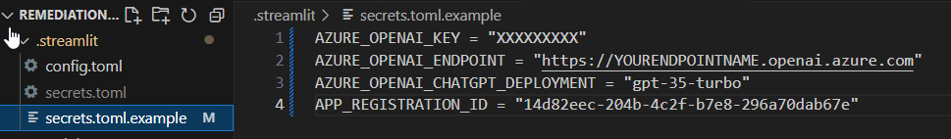

How does the tool work?

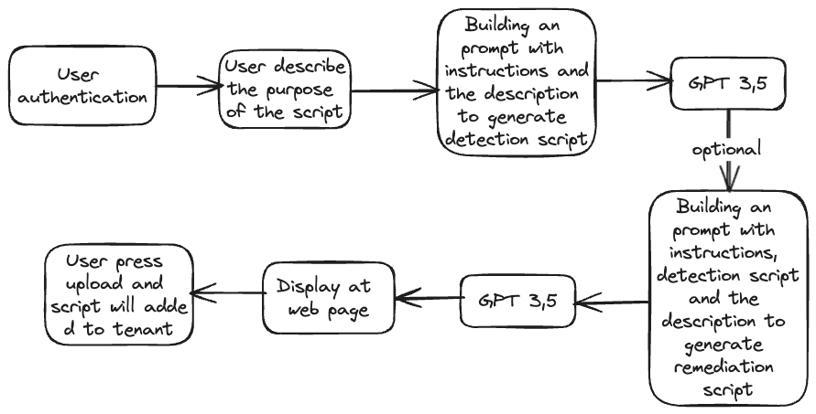

1. **User authentication**: The process starts with user authentication, ensuring that only authorized users can upload scripts using the user token
2. **User describes the purpose of the script**: After authentication, the user provides a description of what the script is intended to do.
3. **Building a prompt with instructions and the description to generate a detection script**: This description, along with instructions, is used to build a prompt for GPT-3.5-turbo, which will then generate a detection script based on the input.
4. **(Optional) Building an additional prompt with instructions, the detection script, and the description to generate a remediation script**: Optionally, a further step involves building another prompt that includes the instructions, the detection script that was generated, and the description. This new prompt is for GPT-3.5-turbo to create a remediation script, presumably to address the issues the detection script identified.
5. **Display at web page**: The scripts or the output from GPT-3.5-turbo are then displayed on a web page.
6. **User presses upload and script will add to tenant**: Finally, the user can press an upload button, resulting in the script being added to the tenant.

How to get access to Open AI Service

Fill out the following [request form](https://customervoice.microsoft.com/Pages/ResponsePage.aspx?id=v4j5cvGGr0GRqy180BHbR7en2Ais5pxKtso_Pz4b1_xUOFA5Qk1UWDRBMjg0WFhPMkIzTzhKQ1dWNyQlQCN0PWcu) to enable you subscription to deploy the OpenAi services.

How it the data privacy when I use the Azure Open AI service

For detailed information on privacy, please refer to this [Microsoft documentation](https://learn.microsoft.com/en-us/legal/cognitive-services/openai/data-privacy). In this scenario, no only personal information is transferred to the service. The only information which is transferred is the script description provided by you.

How to start the GPT Intune Device Troubleshooter

The only thing what you have to do is to run the run.ps1 on Windows or the run.sh on Mac.

Alternativly you can run python -m streamlit run app.py in the terminal. Make sure that the packages in the requirement.txt are installed (*streamlit, azure.identity*)

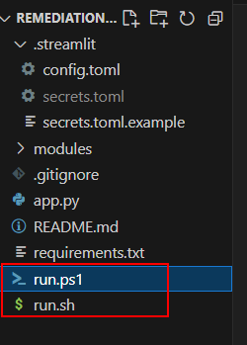

### **Step-by-Step Implementation Guide for Large Organizations Using GPT Remediation Creator**

1. **Understand the Purpose of the GPT Remediation Creator**:
   * This tool simplifies the process of creating scripts for device management and remediation in Microsoft Intune. It allows IT admins to describe configurations in natural language, and then generates both detection and remediation scripts automatically.
2. **Prerequisites Setup**:
   * **Azure OpenAI Access**: Acquire a subscription with GPT capabilities. Register for Azure OpenAI service access through Microsoft’s request form, ensuring it’s enabled for your organization.
   * **Python Installation**: Ensure Python is installed on the system where the tool will run.
   * **Configuration File (secrets.toml)**:
     + Rename secrets.toml.example to secrets.toml in the repository and add your Azure OpenAI deployment details here for secure integration.
3. **Clone the Tool from GitHub**:
   * Clone the repository from GitHub ([link](https://github.com/JayRHa/Remediation-Creator)) to get the source code. This allows easy access to all necessary files, including the configuration examples and prerequisites.
4. **Install Required Packages**:
   * Run the requirements.txt file to install dependencies like **Streamlit** and **azure.identity** by running:

bash

Copy code

pip install -r requirements.txt

1. **Authenticate and Access Azure OpenAI**:
   * **User Authentication**: When you start the application, it will prompt for user authentication, ensuring only authorized personnel can create and upload scripts. Use your organization’s credentials for Azure Active Directory to log in.
2. **Provide Script Description**:
   * **Detection Script Creation**:
     + Describe the purpose of the script in natural language (e.g., “Detect devices with outdated OS versions”).
     + The tool uses GPT-3.5-turbo to generate a detection script based on your description.
   * **Remediation Script Creation (Optional)**:
     + Optionally, enter additional prompts if a remediation script is needed (e.g., “Update devices with outdated OS versions”).
     + The tool uses the initial detection script to develop a complementary remediation script, targeting identified issues.
3. **Generate and Review Scripts**:
   * **Display Output**: Both detection and remediation scripts are displayed on a web interface, allowing administrators to review and verify script accuracy and relevance before deploying.
4. **Deploy the Scripts to Microsoft Intune Tenant**:
   * **Upload Script**: Once reviewed, press the upload button to add the script to your Intune tenant. This allows the organization to implement the remediation directly within the tenant, streamlining deployment.
5. **Run the Application**:
   * On **Windows**: Execute run.ps1 to start the tool.
   * On **Mac or Linux**: Execute run.sh or run python -m streamlit run app.py in the terminal to launch the Streamlit web app.
   * Ensure the web app is accessible to authorized IT personnel for script generation and deployment.
6. **Data Privacy Compliance**:
   * Only the script descriptions you provide are sent to Azure OpenAI; no other personal data is transmitted. Microsoft’s data privacy policies ensure that this information is managed securely.

### **Detailed Description on How GPT Remediation Creator Benefits Large Organizations**

* **Automation of Custom Remediations**: Large organizations often face device management challenges that are not natively supported in Intune. The GPT Remediation Creator automates the generation of these custom remediations, allowing IT teams to resolve configuration issues, ensure compliance, and maintain devices’ optimal health.
* **Increased Efficiency**: By converting natural language instructions into actionable scripts, this tool eliminates the time-consuming task of manual script writing, reducing workload and enabling IT staff to focus on critical tasks.
* **Centralized and Scalable Management**: For large organizations managing thousands of devices, this solution offers a scalable approach to monitor, detect, and remediate issues from a centralized platform. It simplifies Intune configuration, making it feasible to maintain compliance across a diverse device fleet.
* **Data Security and Controlled Access**: With Azure AD-based authentication, access to the tool is restricted to authorized users only, ensuring secure handling of sensitive device and configuration information. Azure’s data protection standards further protect any script descriptions processed by the tool.

This structured approach outlines how large organizations can implement and benefit from the GPT Remediation Creator to maintain an efficient, secure, and scalable device management system.